NETWORK VIRTUALIZATION AND SECURITY

MOLAKE BENEDICT AGAJI
(ST/SWD/HND/24/004)

A SEMINAR PRESENTED TO THE DEPARTMENT OF COMPUTER SCIENCE, SCHOOL OF SCIENCE AND TECHNOLOGY, FEDERAL POLYTECHNIC MUBI, ADAMAWA STATE, NIGERIA

JULY, 2026

NETWORK VIRTUALIZATION AND SECURITY

MOLAKE BENEDICT AGAJI
(ST/SWD/HND/24/004)

A SEMINAR PRESENTED TO THE DEPARTMENT OF COMPUTER SCIENCE, SCHOOL OF SCIENCE AND TECHNOLOGY, FEDERAL POLYTECHNIC MUBI, ADAMAWA STATE, NIGERIA

IN PARTIAL FULFILLMENT OF THE REQUIREMENTS FOR THE AWARD OF HIGHER NATIONAL DIPLOMA (HND) IN SOFTWARE AND WEB DEVELOPMENT

JULY, 2026

Abstract
Network virtualization has emerged as one of the most transformative technologies in modern computer networking. It enables the creation of multiple virtual networks on a shared physical infrastructure, allowing organizations to improve resource utilization, scalability, flexibility, and operational efficiency. Technologies such as Software-Defined Networking (SDN), Network Function Virtualization (NFV), cloud computing, and network slicing have significantly accelerated the adoption of network virtualization across enterprises, data centers, telecommunications networks, and cloud environments. Despite its numerous advantages, network virtualization introduces unique security challenges, including hypervisor attacks, virtual machine escape, unauthorized access, denial-of-service attacks, data leakage, and vulnerabilities associated with multi-tenancy environments. This seminar article examines the concept of network virtualization, its architectures, benefits, security challenges, threats, and mitigation strategies. It further explores emerging trends such as artificial intelligence-driven security, zero-trust architectures, and secure virtualization frameworks for future networks. Recent scholarly literature demonstrates that while network virtualization enhances network agility and cost efficiency, robust security mechanisms are essential for protecting virtualized infrastructures from evolving cyber threats.
Keywords: Network Virtualization, Cybersecurity, Software-Defined Networking (SDN), Network Function Virtualization (NFV), Cloud Computing, Virtual Networks.

Introduction
The rapid advancement of Information and Communication Technology (ICT) has transformed the way organizations design, manage, and utilize network infrastructures. The increasing adoption of cloud computing, Internet of Things (IoT), artificial intelligence (AI), big data analytics, and mobile communication technologies has generated unprecedented demands for scalable, flexible, and efficient network systems. Traditional networking architectures, which rely heavily on dedicated hardware devices such as routers, switches, firewalls, and load balancers, often struggle to meet these dynamic requirements. According to Alnaim (2024), conventional network infrastructures are characterized by limited flexibility, high operational costs, and complex management processes, making them less suitable for modern digital environments.
To address these limitations, network virtualization has emerged as a transformative networking paradigm that abstracts network services and resources from the underlying physical infrastructure. Network virtualization enables multiple virtual networks to operate independently on a shared physical network, thereby improving resource utilization, operational efficiency, and service delivery. Revathi et al. (2025) noted that network virtualization has become a critical component of next-generation communication systems because it allows organizations to dynamically allocate resources, automate network management, and rapidly deploy new services without extensive hardware modifications. The concept of network virtualization is closely associated with the evolution of cloud computing and data center technologies. As organizations increasingly migrate applications and services to cloud environments, the need for flexible and software-driven networking solutions has become more evident. Network virtualization allows cloud service providers to create isolated virtual networks for different users while utilizing the same physical infrastructure. According to Jmila et al. (2024), virtualization technologies have significantly improved the efficiency of cloud infrastructures by enabling dynamic provisioning, workload optimization, and automated service orchestration.
Literature Review
A major breakthrough in network virtualization has been the development of Software-Defined Networking (SDN) and Network Function Virtualization (NFV). SDN separates the network control plane from the data forwarding plane, enabling centralized control and programmability of network resources. This separation allows network administrators to manage network operations through software-based controllers rather than relying solely on hardware configurations. Similarly, NFV virtualizes network functions such as firewalls, routers, intrusion detection systems, and load balancers, enabling them to run as software applications on standard computing platforms. Yazidi et al. (2024), argued that the integration of SDN and NFV has fundamentally transformed network management by providing greater flexibility, agility, and automation in modern communication systems.
Furthermore, network virtualization has become an essential technology in emerging areas such as fifth-generation (5G) networks, edge computing, smart cities, industrial automation, and the anticipated sixth-generation (6G) communication systems. Through technologies such as network slicing, service providers can create multiple virtual networks tailored to specific user requirements while sharing the same physical infrastructure. Domínguez-Dorado et al. (2024) emphasized that network slicing has become one of the most significant applications of network virtualization in 5G environments because it supports diverse service requirements, including ultra-low latency communications, enhanced mobile broadband, and massive machine-type communications.
Despite its numerous advantages, network virtualization introduces new security challenges that differ significantly from those found in traditional network architectures. The abstraction of network functions from physical hardware creates additional attack surfaces that cybercriminals can exploit. Threats such as hypervisor compromise, virtual machine escape attacks, denial-of-service attacks, unauthorized access, side-channel attacks, and data leakage have become major concerns in virtualized environments. According to Zhang et al. (2024), the increasing complexity of virtualized infrastructures requires advanced security mechanisms capable of protecting virtual network functions and ensuring the integrity of virtualized resources.
The centralized architecture commonly employed in SDN environments also presents unique security risks. Because SDN controllers manage network operations centrally, attackers who successfully compromise a controller may gain extensive control over the entire network infrastructure. Similarly, multi-tenant cloud environments introduce concerns regarding data isolation, privacy protection, and resource sharing among different users. Alnaim (2024) observed that securing virtualized networks has become one of the most critical challenges facing network administrators and cybersecurity professionals due to the growing sophistication of cyber threats targeting software-defined infrastructures.
In response to these challenges, researchers and industry practitioners have proposed various security solutions to enhance the protection of virtualized networks. Emerging technologies such as artificial intelligence-based intrusion detection systems, machine learning-driven threat analysis, blockchain-enabled trust management systems, confidential computing, and Zero Trust security architectures are increasingly being integrated into virtualized environments. According to Spiekermann et al. (2024), AI-driven security systems can significantly improve the detection and mitigation of cyber threats in virtualized networks by analyzing large volumes of network traffic and identifying anomalous behaviors in real time. As digital transformation continues to accelerate globally, network virtualization is expected to play an increasingly important role in supporting future communication infrastructures. Its ability to improve scalability, flexibility, automation, and resource efficiency makes it a foundational technology for modern networking environments.
Concept of Network Virtualization
Network virtualization is a modern networking technology that enables the creation of multiple independent virtual networks on a shared physical infrastructure. It involves abstracting network resources and services, including switches, routers, firewalls, load balancers, and communication links, from their underlying physical hardware and presenting them as logical or software-defined entities. This abstraction allows organizations to deploy, manage, and modify network services more efficiently without the need for extensive physical infrastructure upgrades or modifications (Alnaim, 2024).
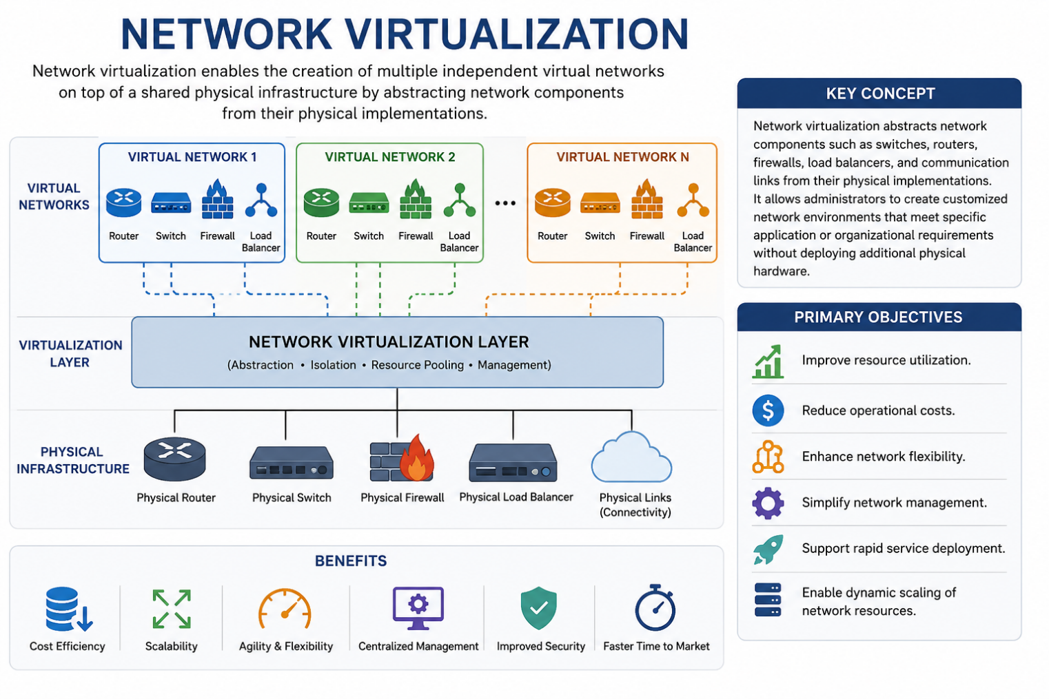
Figure 1: Network Virtualization (Alnaim, 2024).
Through network virtualization, administrators can create customized network environments tailored to specific organizational, application, or user requirements while maintaining isolation between different virtual networks operating on the same physical platform. The technology provides greater flexibility in network design and management, enabling organizations to rapidly adapt to changing business needs and technological demands. According to Revathi, Elamparithi, and Anuratha (2025), network virtualization has become a fundamental component of modern cloud computing and next-generation communication networks because of its ability to improve operational efficiency and service delivery.
The adoption of network virtualization is driven by several strategic objectives aimed at enhancing network performance and resource management. These objectives include:
- Improving resource utilization by maximizing the use of available hardware resources through resource sharing and dynamic allocation.
- Reducing operational and capital costs associated with deploying and maintaining physical networking equipment.
- Enhancing network flexibility by enabling rapid configuration, modification, and deployment of network services.
- Simplifying network management through centralized control and automation mechanisms.
- Supporting rapid service deployment to meet evolving business and application requirements.
- Enabling dynamic scaling of network resources based on workload demands and user requirements (Jmila et al., 2024).
As organizations continue to embrace digital transformation, cloud computing, edge computing, and 5G technologies, network virtualization has become an essential solution for building scalable, efficient, and resilient network infrastructures. Its ability to separate network functions from physical hardware provides the foundation for innovative technologies such as Software-Defined Networking (SDN) and Network Function Virtualization (NFV), which further enhance the agility and programmability of modern networks (Ashraf et al., 2024).
Types of Network Virtualization
Internal Network Virtualization
Internal network virtualization involves partitioning a physical network into multiple virtual networks within a single organization. Technologies such as Virtual Local Area Networks (VLANs) and Virtual Routing and Forwarding (VRF) are commonly used. Internal network virtualization has become increasingly important in modern enterprise environments because it allows organizations to optimize the utilization of existing network resources while maintaining strict control over data traffic and access policies. By creating separate virtual network segments for different departments such as finance, human resources, and administration, organizations can enhance security, reduce network congestion, and improve overall performance. According to Revathi et al. (2025), internal virtualization improves network flexibility and simplifies the implementation of security policies across organizational units. Similarly, Jmila et al. (2024) observed that virtualization technologies enhance resource efficiency by enabling dynamic allocation of network resources based on organizational requirements.
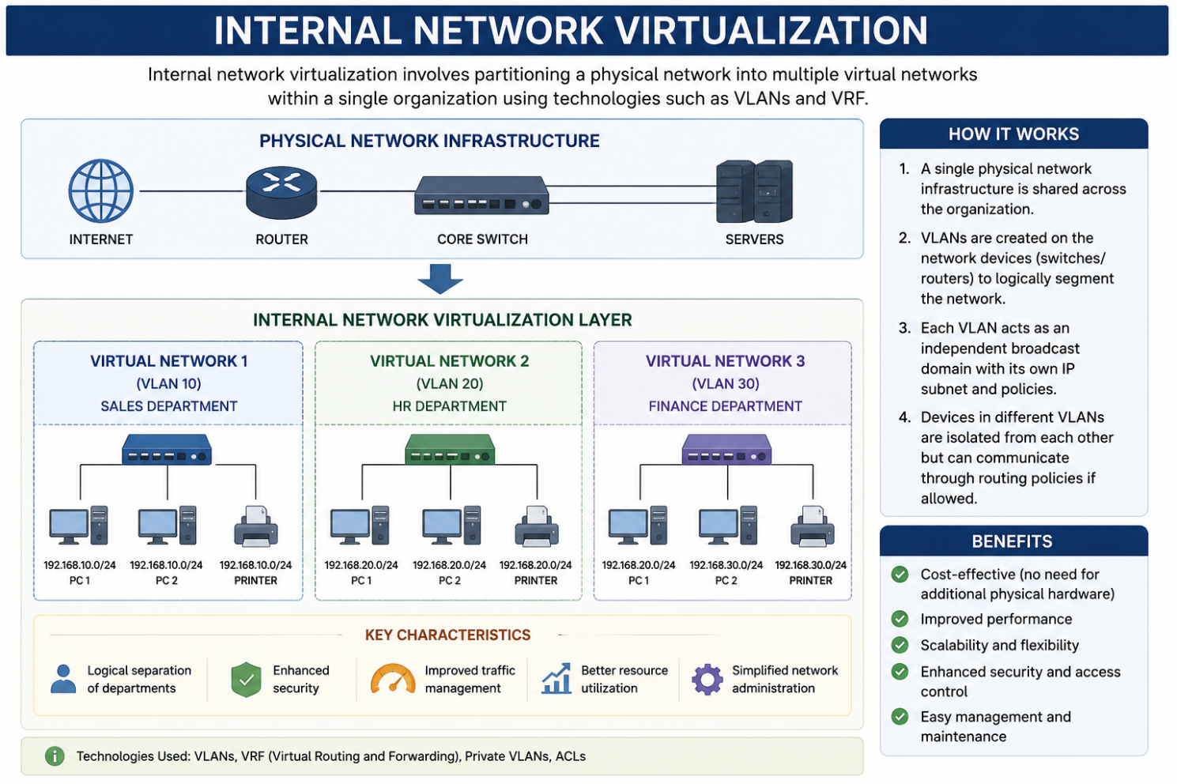
Figure 2: Internal network virtualization (Revathi et al., 2025).
Characteristics of Internal network virtualization
- Logical separation of departments.
- Improved traffic management.
- Enhanced network performance.
- Better resource allocation.
External Network Virtualization
External network virtualization plays a crucial role in modern cloud computing and wide-area networking environments by allowing organizations to interconnect multiple locations and services through a centralized virtual framework. The technology supports remote access, cloud integration, and distributed applications while simplifying network management and reducing operational costs. Alnaim (2024) noted that external virtualization is fundamental to 5G and cloud-native architectures because it enables scalable service delivery and efficient resource sharing across geographically distributed infrastructures. Furthermore, Revathi et al. (2025) emphasized that external network virtualization enhances organizational agility by providing centralized control, improved scalability, and rapid deployment of network services across multiple sites and platforms.
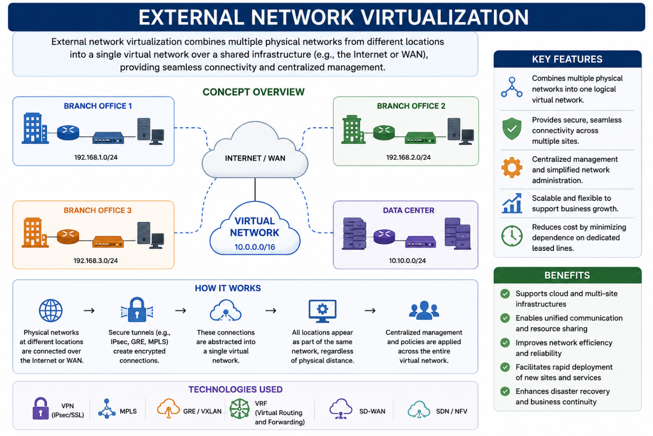
Figure 3: External network virtualization (Revathi et al., 2025).
Characteristics of External network virtualization
- Supports cloud infrastructures.
- Enables multi-site connectivity.
- Simplifies network administration.
- Facilitates service provider operations.

Components of Network Virtualization
Hypervisor: A hypervisor is a software layer that creates and manages virtual machines (VMs). It allows multiple operating systems to run simultaneously on a single physical server. Examples include: VMware ESXi , Microsoft Hyper-V, KVM, Xen
Virtual Switches: Virtual switches connect virtual machines and facilitate communication within virtualized environments.
Functions include:
- Traffic forwarding.
- Packet filtering.
- VLAN management.
- Network monitoring.
Software-Defined Networking (SDN): SDN separates the control plane from the data plane, enabling centralized network management and programmability.
Benefits include:
- Dynamic traffic control.
- Simplified network configuration.
- Improved scalability.
- Enhanced automation.
SDN has become a fundamental component of modern virtualized networks.
Network Function Virtualization (NFV): NFV replaces traditional hardware appliances with software-based virtual network functions (VNFs). Examples include: Virtual Firewalls, Virtual Routers, Virtual Intrusion Detection Systems, Virtual Load Balancers.
NFV significantly reduces infrastructure costs while improving service agility.

Advantages of Network Virtualization
- Cost Reduction: Organizations can reduce capital expenditures (CAPEX) and operational expenditures (OPEX) by minimizing dependence on physical hardware.
- Scalability: Virtual networks can be expanded or reduced based on organizational requirements without physical infrastructure modifications.
- Resource Optimization: Multiple virtual networks share the same physical resources, improving efficiency and utilization.
- Improved Flexibility: Network services can be deployed, modified, or removed quickly through software-based configurations.
- Enhanced Disaster Recovery: Virtualized environments support rapid backup, migration, and recovery mechanisms.
- Automation: Automation tools facilitate dynamic provisioning, monitoring, and management of virtual resources.
- Improved Resource Utilization: Maximizes the use of physical network resources by allowing multiple virtual networks to share the same infrastructure.
- Greater Flexibility: Allows rapid creation, modification, and deployment of network services without requiring physical hardware changes.
- Simplified Network Management: Centralized management tools make configuration, monitoring, and troubleshooting easier.
- Improved Security: Supports network segmentation and isolation, reducing the risk of unauthorized access and lateral movement of cyber threats.
- Faster Service Deployment: New network services and applications can be deployed more quickly through software-based configurations.
- Better Traffic Management: Enables efficient routing and prioritization of network traffic, improving overall performance.

Disadvantages of Network Virtualization
- Security Vulnerabilities: Virtualized environments are susceptible to threats such as hypervisor attacks, VM escape attacks, data breaches, and unauthorized access.
- Complexity of Implementation: Initial deployment and configuration require specialized skills and expertise.
- Performance Overhead: Virtualization layers may introduce latency and consume additional computing resources.
- Dependence on Software: Software failures, bugs, or misconfigurations can affect the entire virtualized network.
- Single Point of Failure: Failure of centralized controllers or hypervisors can disrupt multiple virtual networks simultaneously.
- Management Challenges: Large-scale virtualized environments can become difficult to monitor and manage without appropriate tools.
- High Initial Setup Costs: Although operational costs may decrease over time, the initial investment in virtualization platforms and skilled personnel can be substantial.
Security in Network Virtualization
Security remains one of the most significant concerns in virtualized network environments. Unlike traditional networks, virtualized infrastructures introduce additional layers such as hypervisors, virtual switches, controllers, and management platforms. These layers create new attack surfaces that cybercriminals can exploit. Recent studies indicate that SDN, NFV, and network slicing architectures face increased vulnerability due to their software-centric nature.
The primary goals of network virtualization security include:
- Confidentiality
- Integrity
- Availability
- Authentication
- Authorization
- Accountability
Future of Network Virtualization
The future of network virtualization is closely tied to the development of:
- 5G Networks
- 6G Networks
- Edge Computing
- Cloud-Native Networking
- Artificial Intelligence
- Internet of Things (IoT)
Future virtual networks will become increasingly autonomous, intelligent, and adaptive. However, security must evolve simultaneously to address sophisticated cyber threats targeting virtualized infrastructures. Researchers anticipate that AI-driven security frameworks, secure orchestration mechanisms, and hardware-assisted protection technologies will play critical roles in securing next-generation virtual networks.

CONCLUSION
Network virtualization has fundamentally transformed modern networking by enabling flexibility, scalability, efficiency, and cost reduction. Technologies such as SDN and NFV have facilitated the deployment of agile and programmable networks capable of supporting cloud computing, 5G, and emerging digital services. Despite these advantages, network virtualization introduces significant security challenges, including hypervisor attacks, VM escape, DDoS attacks, data leakage, and multi-tenancy risks. Effective security strategies such as encryption, access control, intrusion detection systems, network segmentation, and continuous monitoring are essential for protecting virtualized environments. As organizations increasingly adopt virtualized infrastructures, integrating advanced security mechanisms, artificial intelligence, zero-trust architectures, and trusted execution technologies will be critical to ensuring secure and resilient future networks.
Recommendations
Based on the discussion of network virtualization and its associated security challenges, the following recommendations are proposed:
- Organizations adopting network virtualization should deploy comprehensive security frameworks that incorporate firewalls, intrusion detection and prevention systems (IDPS), encryption technologies, and access control mechanisms to protect virtualized network environments from cyber threats.
- Organizations should implement a Zero Trust security model where every user, device, and application is continuously authenticated and authorized before accessing network resources. This approach minimizes the risk of unauthorized access and insider threats.
- Hypervisors, virtual machines, virtual network functions, and network management platforms should be regularly updated and patched to address known vulnerabilities and reduce the likelihood of successful cyberattacks.
- Strong authentication methods such as Multi-Factor Authentication (MFA), Role-Based Access Control (RBAC), and least-privilege principles should be enforced to prevent unauthorized access to virtualized resources.
- Organizations should deploy continuous monitoring solutions and AI-powered threat detection systems capable of identifying unusual network behavior, detecting intrusions, and responding to threats in real time.
- Governments, academic institutions, and technology organizations should invest in research focused on advanced virtualization security technologies, including artificial intelligence, machine learning, blockchain, confidential computing, and secure orchestration frameworks for next-generation networks.

References
Alnaim, A. K. (2024). Securing 5G virtual networks: A critical analysis of SDN, NFV, and network slicing security. International Journal of Information Security, 23(6), 3569–3589.
Ashraf, Z., Sohail, A., & Iqbal, M. (2024). Design and implementation of lightweight certificateless secure communication scheme on industrial NFV-based IPv6 virtual networks. Electronics, 13(13), 2649.
Domínguez-Dorado, M., Calle-Cancho, J., Galeano-Brajones, J., Rodríguez-Pérez, F. J., & Cortés-Polo, D. (2024). Detection and mitigation of security threats using virtualized network functions in software-defined networks. Applied Sciences, 14(1), 374.
Jmila, H., Khedher, M. I., & El-Yacoubi, M. A. (2024). The promise of applying machine learning techniques to network function virtualization. International Journal of Networked and Distributed Intelligence, 1(2), 1–20.
Revathi, N., Elamparithi, M., & Anuratha, V. (2025). Adaptive and intelligent security frameworks for SDN-NFV enabled next-generation networks: A review. International Journal of Computational and Experimental Science and Engineering, 11(2), 455–469.
Spiekermann, D., Eggendorfer, T., & Keller, J. (2024). Deep learning for network intrusion detection in virtual networks. Electronics, 13(18), 3617. https://doi.org/10.3390/electronics13183617
Yazidi, M., Alghamdi, A., & Alharbi, F. (2024). A multi-layered defence strategy against DDoS attacks in SDN/NFV-based 5G mobile networks. Electronics, 13(8), 1515.
Zhang, X., Wang, Y., & Liu, H. (2024). TVRAVNF: An efficient low-cost TEE-based virtual remote attestation scheme for virtual network functions. Cybersecurity, 7(39), 1–21. https://doi.org/10.1186/s42400-024-00235-7

